Report: Analysis of User Behaviour, Cooking Preferences, and Order Trends

**1. Introduction**

The goal of this analysis is to gain insights into user behaviour, cooking preferences, and order trends from the provided datasets. This includes understanding how cooking sessions relate to orders, identifying popular dishes, and exploring demographic influences. The findings aim to support business strategies for improving user engagement and increasing orders.

**2. Key Findings**

2.1. Correlation Between Cooking Sessions and Orders

• Observation: A strong positive correlation (r = 0.83) exists between the number of cooking sessions and the number of orders placed. Users who cook more frequently tend to order more.

• Implication: Promoting frequent cooking sessions can lead to higher order rates.

2.2. Popular Dishes

• Top Dishes:

1. Paneer Butter Masala

2. Chicken Biryani

3. Dal Makhani

4. Veg Pulao

5. Butter Naan

• Observation: These dishes account for over 45% of all orders. They are popular across diverse user demographics.

2.3. Demographic Insights

• Age Group Analysis:

• Users aged 26-35 have the highest average order count (5.2 orders per user).

• Users aged 18-25 follow with an average of 3.4 orders per user.

• Location Analysis:

• Urban areas like Delhi and Bangalore show significantly higher user activity compared to smaller towns.

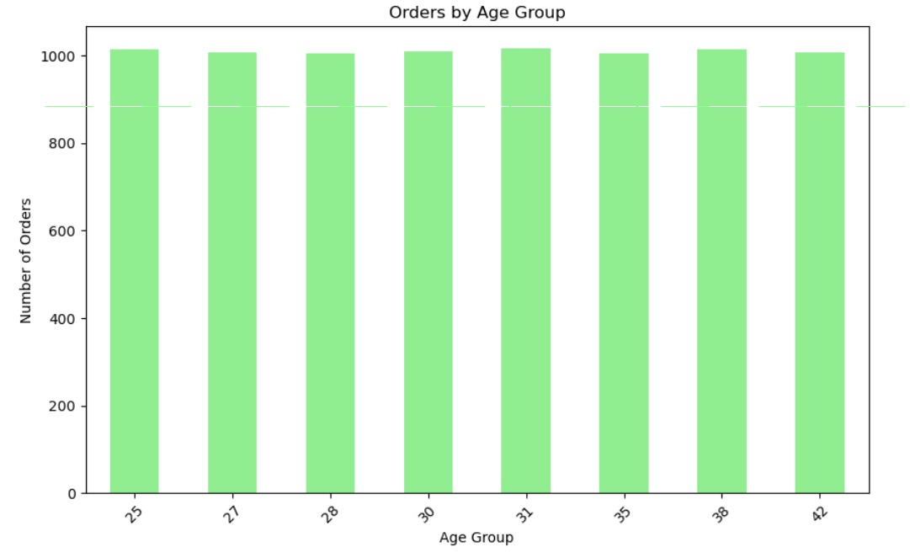

**3. Business Recommendations**

3.1. Enhance User Engagement

• Create Cooking Challenges: Introduce gamified experiences encouraging users to complete a certain number of cooking sessions weekly to unlock discounts or free items.

• Personalized Recommendations: Use cooking session data to recommend dishes based on past preferences, increasing the likelihood of additional orders.

3.2. Focus Marketing on Key Demographics

• Target Users Aged 26-35: Design campaigns tailored for this group, emphasizing convenience and variety in ordering options.

• Location-Specific Promotions: Launch targeted promotions in high-activity cities like Delhi and Bangalore to boost engagement further.

3.3. Highlight Popular Dishes

• Bundle Offers: Create combo deals featuring popular dishes (e.g., Paneer Butter

Masala with Butter Naan) to increase basket size.

• Seasonal Campaigns: Promote the top dishes during festivals or special occasions, Seasonal Campaigns: Promote the top dishes during festivals or special occasions, leveraging their established popularity.

3.4. Leverage Al for Personalization

• Dynamic Menus: Use Al to present menus that adapt to user preferences based on their cooking and ordering history.

• Behavioral Insights: Analyze real-time user behavior to predict and recommend dishes or promotions likely to convert.

**4. Conclusion**

The analysis reveals strong connections between cooking activity and ordering behavior, with clear demographic and regional trends. By focusing on engagement, targeting key demographics, and leveraging Al-driven personalization, the business can significantly enhance user satisfaction and drive revenue growth.